Phase 5

Total classes : 10

Day 2 : 6 Feb 2024

Test NG : Next Generation

Unit Testing : provide normal java class as Testing Suite

Test NG : provide xml file as Testing Suite

Test NG Hooks

Test NG Support priority testing concept.

Group testing

CarTest

speedTest() speed as group

mailageTest()

colorTest()

BikeTest

speedTest() speed as group

mailageTest()

wheelAlignmentTest()

BusTest

speedTest() speed as group

mailageTest()

colorTest()

Spring boot Testing

Controller, Service, Bean, Repository layer with database mysql

Spring boot with spring interlizer

By default testing starter added.

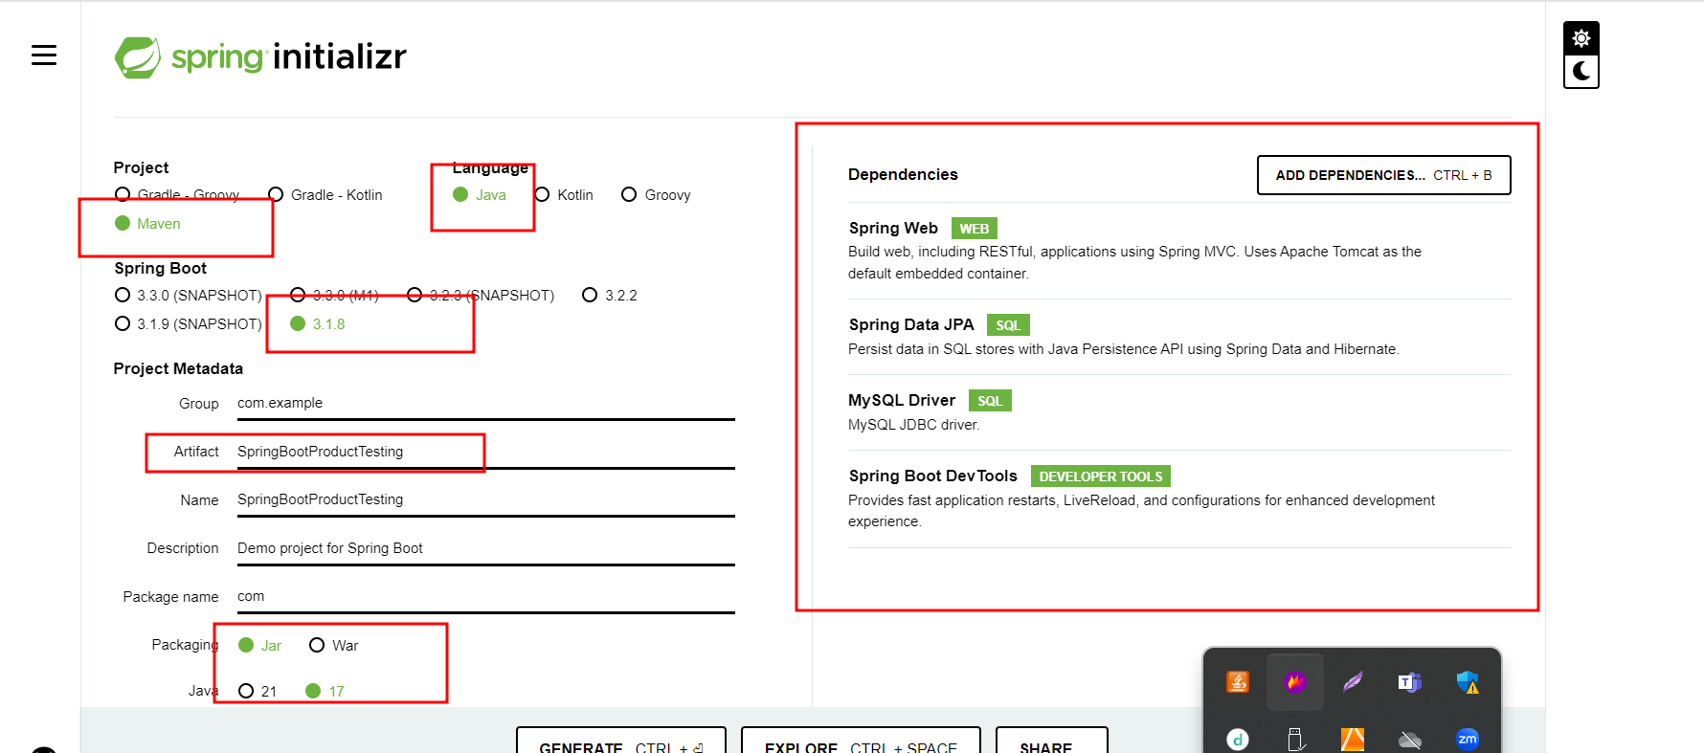

@RequestMapping : This annotation we can use for class level as well as method level with method attribute as Get, Post, Put , Delete etc.

@GetMapping(GET), @PostMapping(POST), @PutMapping(PUT), @DeleteMapping(Delete)

These annotation we can use on method level only with not method attribute